МИНИСТЕРСТВО ОБРАЗОВАНИЯ И НАУКИ РОССИИ
ФЕДЕРАЛЬНОЕ ГОСУДАРСТВЕННОЕ АВТОНОМНОЕ
ОБРАЗОВАТЕЛЬНОЕ УЧРЕЖДЕНИЕ ВЫСШЕГО ОБРАЗОВАНИЯ
«САМАРСКИЙ НАЦИОНАЛЬНЫЙ ИССЛЕДОВАТЕЛЬСКИЙ УНИВЕРСИТЕТ ИМЕНИ АКАДЕМИКА С.П.КОРОЛЕВА»

Институт информатики и кибернетики
Инженерия программного обеспечения
DevOps
Отчёт по лабораторной работе №1
«VM and RAID1»

Выполнил: Усанов К.В.
Группа: 6411-100503D
Проверил: Авдеев Е.В.

Самара 2022

Steps
- Create Virtual Machine with Debian/Ubuntu/CentOS or download preinstalled image (https://www.osboxes.org/). VM without GUI.
- Add simple RAID1 to Virtual Machine: *nix OS System on 1-st HDD, 2d and 3d HDDs are in RAID1. 2 (with star). only two HDDs. OS System on RAID1, based on this two HDD.
- How to test RAID1. Create file on RAID1 file system. Turn off VM and remove one of the HHDs from VM. Turn on VM. File should be accessible.
- Add new HDD and sync it to RAID1.
- Add section with Assignment1 description into docx and send by e-mail for checking.
Completing
- Install Debian Server on VirtualBox and add two hard drives.
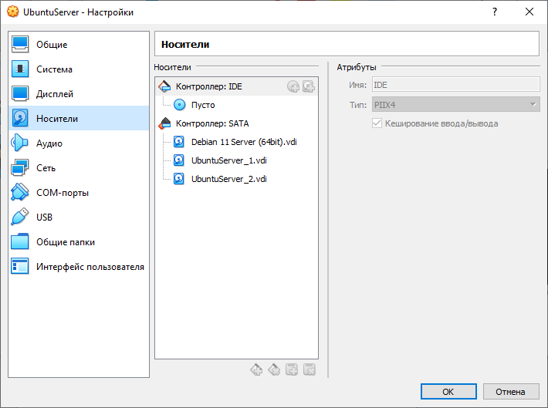
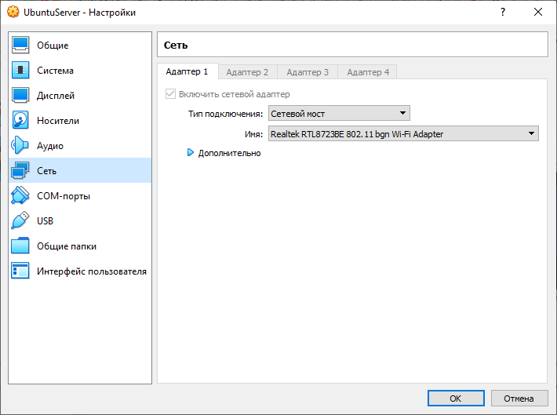
- Find out the ip address of the virtual machine and connect to it from Windows via SSH using PuTTY.
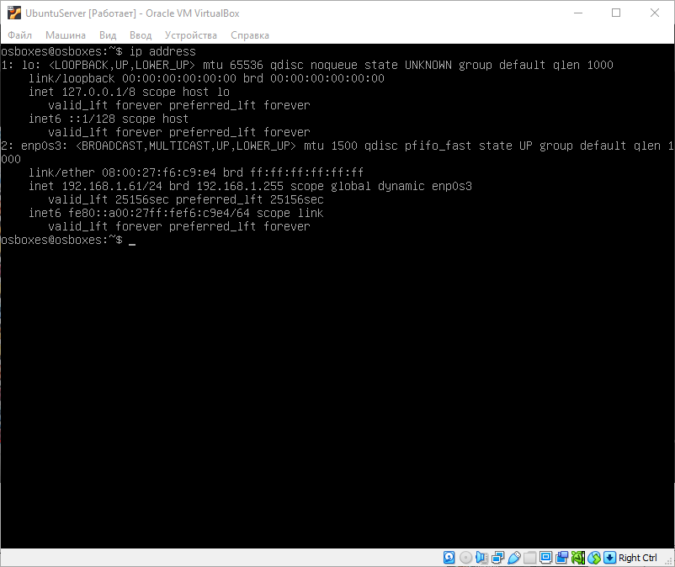
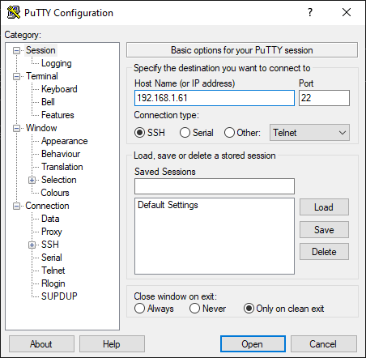
- Let’s see information about disks and partitions.
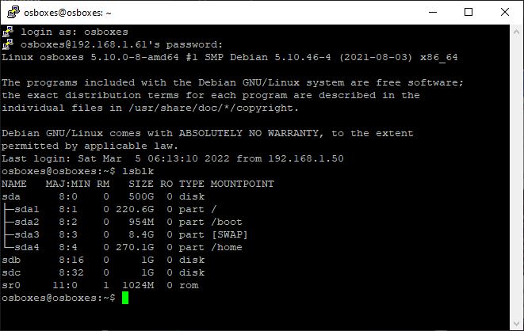
- Create partitions sdb1 and sdc1 on disks sdb and sdc respectively.
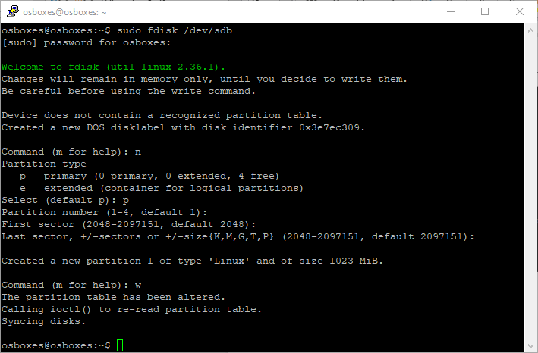
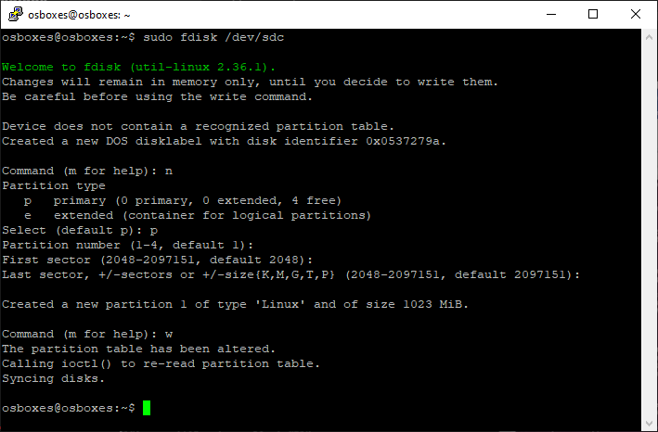
- Create RAID1 disks sdb and sdc array.
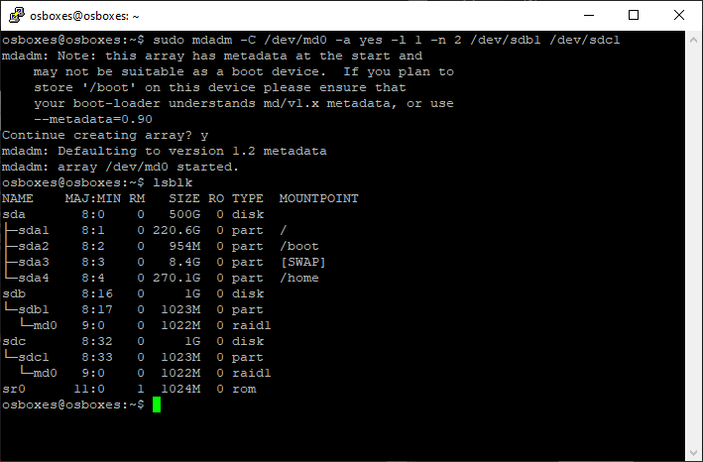
- Mount the file system ext4 on RAID1.
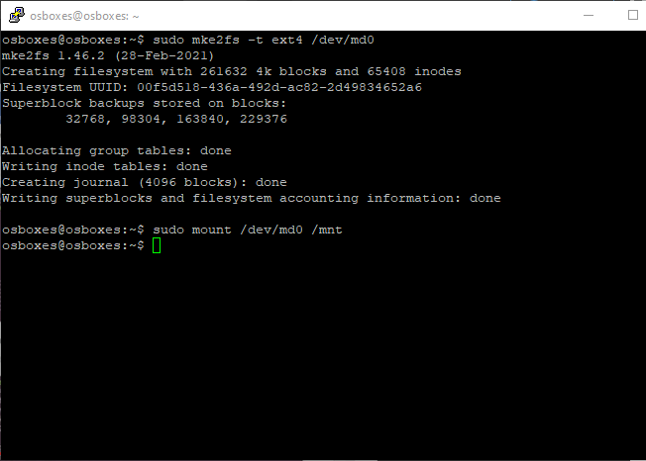
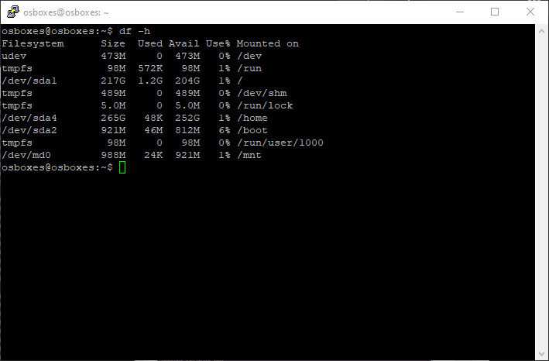
- Save the changes so that they are used when the system boots.
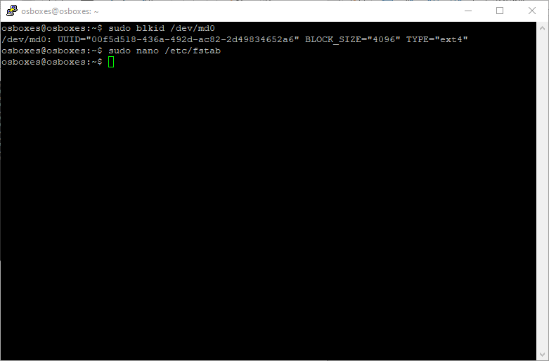
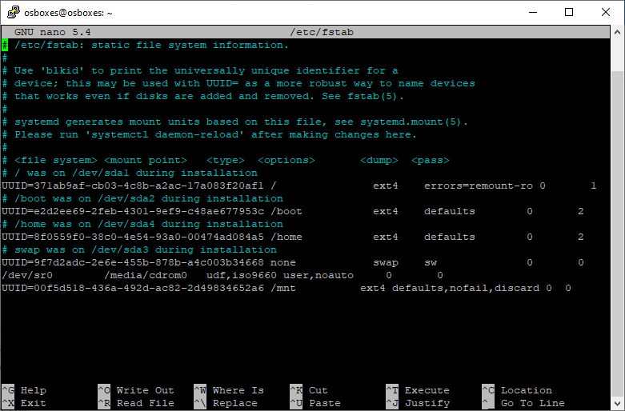
- Using the Midnight Commander, go to the folder, create a file there and write some text to it.
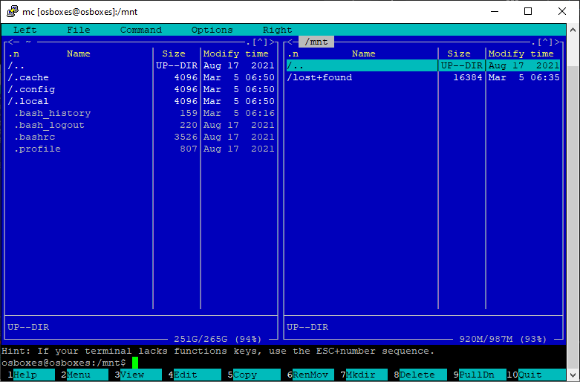
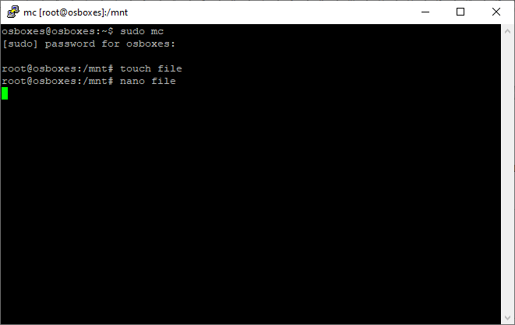
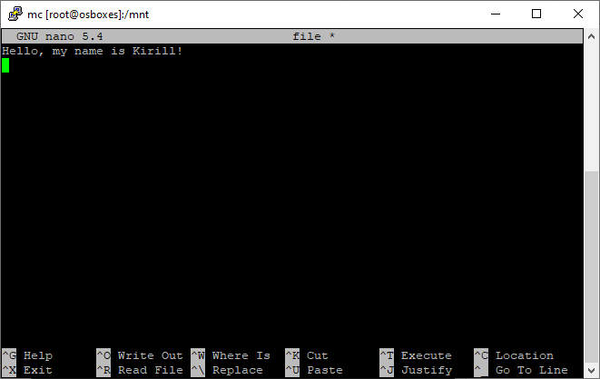

- Remove one disk from RAID1 and check the existence and contents of file.
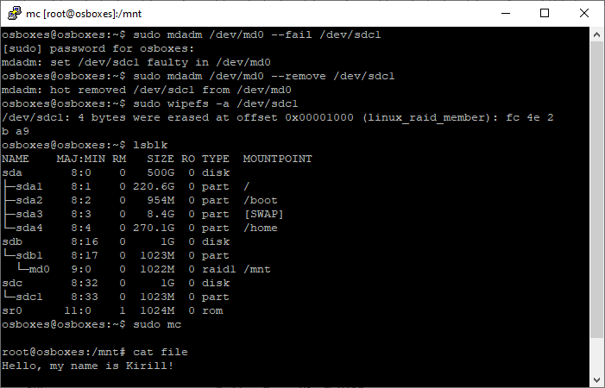

- Remove one disk from the virtual machine and add another. Let’s check the existence and contents of the file after removing the old disk from virtual machine and after adding a new disk to RAID1

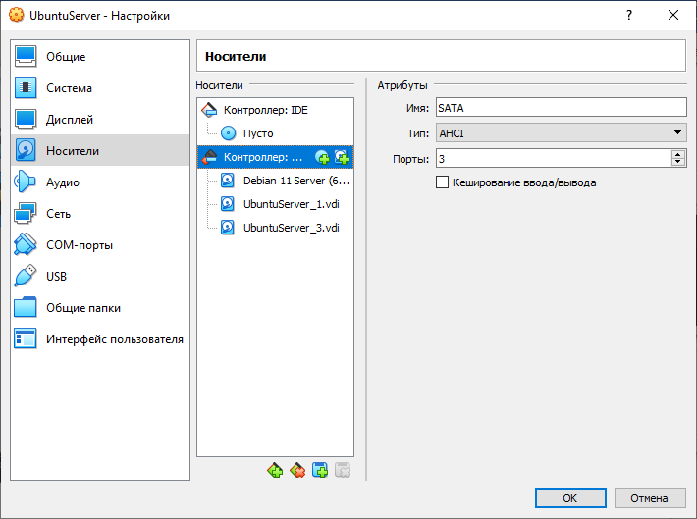
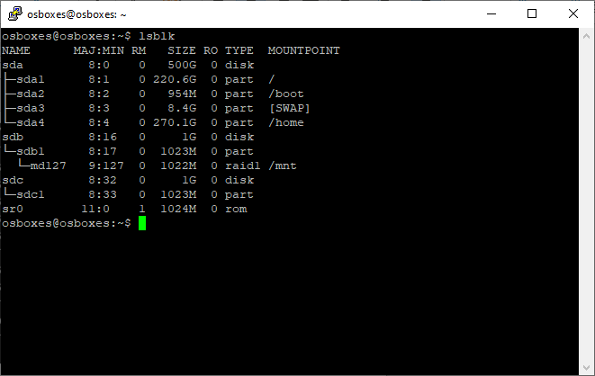
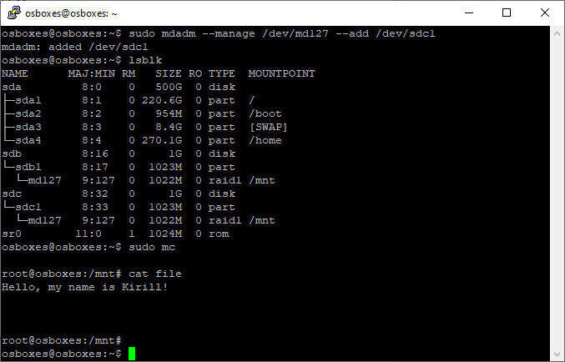

Conclusion
During the laboratory, we studied data virtualization technology for combining multiple physical disk devices into a logical unit to improve fault tolerance and (or) performance.

